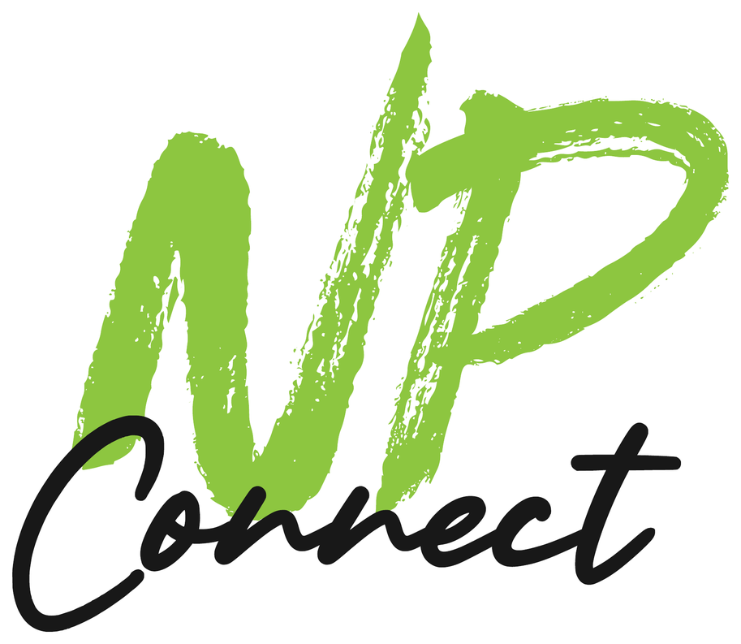
NP CONNECT | BRAND TOOLKIT
Tone of Voice
& Social Messaging Template
Identify your tone of voice to ensure consistent communication. This easy to use template helps you define how you message your audience on social media... and everywhere else you show up.
Cover up your logo. Could people still tell the post was yours? If the answer is "probably not," this template is for you. You'll define who you sound like, how that flexes from a Tuesday tip to a one-star review, the words you use (and never use), and how to train your AI tools so they stop sounding like a robot wrote everything. Because one did.

Pick your path
The Fast Track  Let AI find the voice you already have.  1. Grab 10 to 20 posts, emails or captions that sound the most like you.  2. Run the Voice Extractor prompt (Step 6).  3. Paste the results into this template and fix anything that sounds off.  4. Save it as your AI's custom instructions and test it with a real post. | The Full Workshop  Get the team in a room.  1. Fill out Step 1 together. If you've done the Target Client Profile template, steal from it.  2. Argue about your traits (Step 2) and tone dials (Step 3). The arguing is the point.  3. Write the rules (Steps 4 and 5).  4. Fill in the one-page voice guide at the back and give it to anyone who posts for you.

HOW TO READ THIS TEMPLATE
[Text in green brackets] = fill this in.
Gray italic text = examples from NP Connect's own voice. Read it, steal the format, then delete it.

PICKLE POINT
"You don't need to go viral... you need to stay visible and credible while people are deciding."
Nick Packard

NP CONNECT | WHY IT MATTERS

What your audience wants from you
People follow brands for the same reason they follow people: they like how they talk. Here's what the research says your audience is looking for on social.
Top 2  Authenticity and relatability are the traits consumers value most from brands on social.  Sprout Social Index 2025, 4,044 consumers | 73%  will buy from a competitor if a brand doesn't respond on social. Your replies are part of your voice.  Sprout Social Index 2025 | 1 in 3  consumers think brands jumping on viral trends is embarrassing. Be you, not the meme of the week.  Sprout Social Index 2025
~50%  say original content is what makes their favorite brands stand out.  Sprout Social Index 2025 | 53%  are less likely to buy from brands they know use AI in their social content.  Clutch, 601 consumers, August 2026 | ~90%  say brands and creators should disclose AI-generated social content.  Clutch, 601 consumers, August 2026

WHAT THIS MEANS (IN PLAIN ENGLISH)
Sound like a person. Authentic and relatable beats polished and corporate every time.
Your replies count. A great post followed by a robotic (or missing) reply undoes all of it.
Use AI, but don't sound like AI. People are suspicious of AI content. Let it draft, then make it yours. This template gives AI the instructions it needs to get closer on the first try.

Voice vs. tone (they're not the same thing)
 | What it is | Does it change? | Example
Voice | Your personality. Who you are. | Never. It's you at a ball game and you at a funeral. | Straight-talking, funny, helpful.
Tone | How that personality adjusts to the moment. | All the time. You don't tell the same jokes at both. | Fun on a Tuesday tip. Calm and careful on a bad review.
Research from Nielsen Norman Group backs this up: in their testing, tone changed how trustworthy people found a website, even when everything else was identical. The right tone depends on the situation, which is exactly what Step 3 is for.
NP CONNECT | STEP 1

Your foundation
Your voice has to come from somewhere. Get clear on your story, your role on social, your talking points and your audience first.

Our story (the short version)
THREE OR FOUR SENTENCES. WHERE YOU CAME FROM, WHAT YOU DO, WHY IT MATTERS.
[Our story]

EXAMPLE (NP CONNECT)
I started NP Connect after years of bad bosses and side hustles. When 2020 hit, I hammered a farting pickle sign into a yard... and it saved my business. Now I help small businesses do marketing that actually gets noticed, without a big budget.

Our mission on social (our role)
What is social actually FOR in your business? Be specific. "Brand awareness" is not a mission. It's a shrug.
Our role on social | How we'll know it's working
1. [Role] | [Signal: comments, DMs, shares, leads, hires...]
2. [Role] | [Signal]
3. [Role] | [Signal]
Example: Teach practical marketing (Tuesday Tips), prove "stupid" ideas work, stay visible while people decide. Signals: saves, DMs, "I see you everywhere."

Brand attributes (what we always come back to)
Three talking points you'll repeat until you're sick of them... which is about when your audience starts to remember them.
TALKING POINT 1 | TALKING POINT 2 | TALKING POINT 3
[Talking point] | [Talking point] | [Talking point]
Example: 1) Stupid ideas, smart marketing. 2) Clarity before scale. 3) A partner, not an agency.

Who we're talking to (your buckets from the Target Client Profile)
Audience | What they're like | What they want from us on social
[Audience 1]
[Audience 2]
[Audience 3]
Example: B2B leaders and owners: short on time, want real advice. Agencies: want a reliable creative partner.
NP CONNECT | STEP 2

Your personality: this, not that
Pick 3 to 5 traits. Here's the trick most people miss: a trait means nothing without its guardrail. "Friendly" could mean anything from a golden retriever to a used car salesman. So every trait gets a "but not."
We are... | But not... | What it sounds like
[Trait 1] | [The ditch on the other side] | [A real sentence you'd write]
[Trait 2] | [But not] | [Sounds like]
[Trait 3] | [But not] | [Sounds like]
[Trait 4] | [But not] | [Sounds like]
[Trait 5] | [But not] | [Sounds like]
EXAMPLE (NP CONNECT)
We are... | But not... | What it sounds like
Straight-talking | Rude or preachy | "Clarity converts... not animations."
Funny with a point | A clown. Every joke has to sell the idea. | "Hats, shirts, koozies don't fix unclear messaging."
Helpful first | Salesy | "Here's a simple, practical framework I give early-stage companies all the time."
Confident | Cocky. We make fun of ourselves first. | "Mostly money... I had none. But I knew it was a great idea."
Real | Sloppy | "Consistency > perfection."

Identity: who we are and who we're not
A few more lines to round out the personality. Use the same "X, but not Y" format.
Who we are | Who we are not
Example: Personable, but not unprofessional. Well-informed, without being a know-it-all. Creative, but always tied to results. Local (Wisconsin) roots, without being small-time.
PICKLE POINT
"Funny is not the strategy by itself. Humor makes the strategy easier to remember."
Nick Packard

NP CONNECT | STEP 3

Tone dials: where you sit, and when you move
Nielsen Norman Group breaks tone into four dimensions. Check where your default lands on each one. This is your setting on a normal day... we'll adjust for the not-normal days below.
Funny |  |  |  |  |  | Serious
Formal |  |  |  |  |  | Casual
Respectful |  |  |  |  |  | Irreverent
Enthusiastic |  |  |  |  |  | Matter-of-fact
Example: NP Connect sits at box 2 on funny, box 5 on casual, box 4 on irreverent and box 2 on enthusiastic. A law firm would probably flip most of those. Neither one is wrong.

How our tone shifts by situation
Voice stays the same. Tone moves. Decide now, while you're calm, instead of at 9 PM when someone's yelling at you in the comments.
Situation | Turn up | Turn down | Our note
Tips and education | Helpful, clear, specific | Jokes (one, max) | [Note]
Wins and shout-outs | Enthusiasm, gratitude, credit to others | Bragging | [Note]
Promos and offers | Clarity, honest urgency | Hype, ALL CAPS, fake deadlines | [Note]
Complaints and bad reviews | Empathy, ownership, speed | Humor, defensiveness | [Note]
Tough news (local or national) | Respect, brevity | Humor, hot takes, scheduled promos | [Note]
Trolls | Calm, facts | Sarcasm (even when it's SO tempting) | [Note]

Touchy subjects (staying within the brand)
How do you handle a sensitive topic, a heated comment or a public mistake? Write the rules down before you need them.
Our guardrail | Your answer
Topics we take a stand on
Topics we never touch
Who approves sensitive replies
When we take it offline
When we hide or delete a comment
EXAMPLE (NP CONNECT)
- We're open to a respectful conversation, but we'll also look to educate.
- We take a stand, but we don't get defensive.
- We own our mistakes fast and publicly. Then we fix them privately.
- When it gets heated, we take it offline (DM, email or phone) after one public reply.
- We pause scheduled posts when something big and bad is happening. Nobody wants a pickle joke during a tragedy.
- We only hide or delete spam, threats and hate. Criticism stays up and gets a real answer.
NP CONNECT | STEP 4

The details: words and style rules
This is where a voice guide earns its keep. Small, specific rules are what make 10 different people (and an AI) sound like one brand.

Linguistic cues: we are / we are not
We are... | But we are not...
[We get excited about...] | [But not too excited... e.g., no emojis or exclamation points as a crutch]
[We are rooted in...] | [But we don't assume people know why it matters]
[We use...] | [But we don't go overboard]
Example: We get excited about a good idea... but we don't use exclamation points to fake it. We use real talk... but we never talk down to anyone. We use emojis as visual bullets on LinkedIn... but never in place of words.

Words we love / words we never use
Words and phrases we use | Words and phrases we never use
EXAMPLE (NP CONNECT)
We use | We never use
- Real talk  - Stupid idea (as a compliment)  - Clarity, system, partner  - Tuesday Tip  - "Here's the thing..." | - Synergy, best-in-class, cutting-edge  - Unlock, elevate, delve, seamless  - "In today's fast-paced world..."  - "We're passionate about..."  - Anything we wouldn't say out loud

Style rules
Element | Our rule | Example
Emojis | [Rule] | Visual bullets on LinkedIn (check mark, stop sign, pointing finger). Never more than one in a sentence.
Exclamation points | [Rule] | One per post. Max.
Hashtags | [Rule] | 1 to 3 relevant ones. Instagram caps you at 5 anyway. Capitalize each word (#SmallBusinessMarketing) so screen readers can read it.
Punctuation | [Rule] | Ellipses yes... long dashes never. They make writing look AI-generated.
Capitalization | [Rule] | Sentence case for headlines. ALL CAPS for one word of emphasis, tops.
Slang and swearing | [Rule] | Real talk is fine. Swearing only in context, never aimed at a person, never in customer replies.
Length and format | [Rule] | Hook in the first line. Short paragraphs. White space is your friend.
I vs. we | [Rule] | "I" on Nick's personal posts. "We" on the company page.
Reading level | [Rule] | 8th grade or lower. If your mom wouldn't get it, rewrite it.
Call to action | [Rule] | One clear ask per post: "Message me any time!"
Accessibility | [Rule] | Alt text on every image. Captions on every video. Emojis get read out loud by screen readers, so don't stack them.
NP CONNECT | STEP 5

Platform playbook and replies
Same person, different rooms. You talk differently at a networking breakfast than at a backyard barbecue, but you're still you. Fill in the platforms you actually use. Skip the rest. You don't need to be everywhere.
Platform | Why we're there | Tone adjustment | Format tips
LinkedIn | [Why] | The most professional version of us. Still human. | Hook in the first line or two. Short lines. Posts from people usually beat company pages.
Facebook | [Why] | Warmer and chattier. Community first. | Ask questions. Be active in local groups. Reply to every comment.
Instagram | [Why] | Playful. Visual first. | The visual does the work, the caption backs it up. Max 5 hashtags. Caption your Reels.
TikTok / Reels / Shorts | [Why] | The loosest version of us. | Hook in the first few seconds. On-screen text. Show your face.
YouTube | [Why] | Teacher mode. | Titles that answer a real search. Chapters on longer videos.
Google reviews | [Why] | Grateful, specific, calm. | Reply to every review, good and bad. Use their name.
Email / newsletter | [Why] | One-to-one. Like a note to a friend. | One idea per email. Plain text often wins.

Replies, comments and reviews
Your reply is a post too. And 73% of people will go to a competitor if you don't respond at all. Here are templates for the four you'll write most.
POSITIVE REVIEW OR COMMENT
"Thanks, [First name]! [Something specific about what they said or what you did together]. [Small human touch.] [Optional: an invite to come back or stay in touch.]"

EXAMPLE (NP CONNECT)
"Thanks, Dave! Watching your team's new site go live was a blast. Next round of coffee is on me."

NEGATIVE REVIEW OR COMPLAINT
"[First name], thanks for telling us. [Own it: what went wrong, no excuses.] That's not the experience we want anyone to have. [What you're doing about it.] I'd like to make it right... can you [call / email] me at [contact]?"

EXAMPLE (NP CONNECT)
"Dave, thanks for telling me. I missed the deadline we agreed on, and that's on me. That's not how I want anyone to feel about working with NP Connect. I'd like to make it right... can you call me at [number]?"

QUESTION IN THE COMMENTS
"Great question, [First name]. [Short, helpful answer.] [If it needs more: I'll DM you / here's a link]."

THE TROLL
One calm, factual reply. Then stop. "[Acknowledge their point.] [One fact.] Happy to talk more at [contact]." If they keep going, you're done. Hide only if it's spam, a threat or hate.

NP CONNECT | STEP 6

AI tips and tricks
AI can write a hundred posts before lunch. The problem is they all sound like the same guy... and he's boring. Here's how to make AI sound like you instead.

The ground rules
- Show, don't tell. "Friendly and professional" means nothing to an AI (or a human). Paste in real examples of your best writing. Examples beat adjectives every time.
- Give it the "not" list. Your "but not" column, your banned words and your style rules are the most useful things you can give it.
- Make it permanent. Save your voice guide as custom instructions, a Claude Project, a custom GPT, a Gemini Gem or a Copilot agent so you don't paste it every time.
- A human edits everything. AI drafts. You decide. Read it out loud before it goes out.
- Be honest about AI. About 9 in 10 people want AI-generated content disclosed. Label AI images and anything that shows people or events that aren't real. Never use AI to fake reviews, testimonials or stats.

PROMPT 1: VOICE EXTRACTOR
"Here are [10 to 20] pieces of writing that sound the most like us: [paste posts, emails, captions]. Analyze them and build a tone of voice guide with: 3 to 5 personality traits, each with a 'but not' guardrail and an example sentence from our writing; where we sit on funny/serious, formal/casual, respectful/irreverent and enthusiastic/matter-of-fact; words and phrases we use often; our style habits (emojis, punctuation, length, hashtags); and anything that seems inconsistent. Only use evidence from what I gave you."

PROMPT 2: BUILD MY AI'S CUSTOM INSTRUCTIONS
"Turn the tone of voice guide below into custom instructions for an AI writing assistant, under 400 words. Include the traits with their 'but not' guardrails, the style rules, the banned words, and 3 short examples of on-voice writing. Write it as direct instructions. [paste guide]"

PROMPT 3: REWRITE IT IN OUR VOICE
"Rewrite this draft in our voice using the guide below. Keep the facts exactly the same. Then show me 2 lines you changed the most and why. Guide: [paste]. Draft: [paste]"

PROMPT 4: DE-ROBOT THIS
"Edit this to remove anything that sounds AI-written: long dashes, 'it's not X, it's Y' setups, everything in groups of three, filler openers like 'In today's world', words like delve, elevate, unlock and seamless, and sentences that are all the same length. Make it sound like a real person talking. Don't add new claims. [paste]"

PROMPT 5: TONE GRADER
"Score this post from 1 to 10 against each trait in our voice guide and our style rules. For anything under 8, tell me exactly what to change. Be blunt. Guide: [paste]. Post: [paste]"

PROMPT 6: ONE IDEA, EVERY PLATFORM
"Here's one idea: [idea]. Using our voice guide, write versions for LinkedIn, Facebook, Instagram (caption and up to 5 hashtags) and a 30-second video script. Adjust the tone for each platform using our platform playbook. Guide: [paste]"

PROMPT 7: REPLY DRAFTER
"Draft a reply to this [review / comment] in our voice. Follow our tone rules for [situation]. If it involves a refund, a legal issue, a safety issue or an angry customer, draft a short public reply that takes it offline and flag it for a human. Guide: [paste]. Comment: [paste]"

Spot the robot (run this before you post)
AI tell | Gone?
Long dashes everywhere
"It's not just X... it's Y" setups
Everything in groups of three
Openers like "In today's fast-paced world" or "Let's dive in"
Words like delve, elevate, unlock, seamless, tapestry, journey
Every sentence about the same length
No specific detail (names, numbers, places, stories)
An emoji at the start of every single line
NP CONNECT | STEP 7

Keep it consistent
A voice guide only works if people actually use it. Make it part of the routine, not a PDF that dies in a shared drive.

Before you post: the 30-second check
Check | Done
Does it sound like us when you read it out loud?
Does it hit at least one of our traits, without falling into the "but not"?
Is the tone right for the situation (and for what's in the news today)?
Does it follow our style rules (emojis, hashtags, punctuation)?
Would someone in our audience actually understand it?
Is there one clear call to action (or a good reason there isn't)?
Alt text and captions added?
If AI helped, did a human edit it? Are AI images labeled?

Who owns the voice
Role | Name
Voice owner (final say on what sounds like us)
Approves sensitive replies and touchy subjects
Posts and replies day to day
Freelancers, agencies and new hires who get this guide
Where the guide and AI instructions live

Keep it fresh
When | What to do | Done
Every quarter | Pull your top 10 and bottom 10 posts. What did the voice do in each? Update your word lists and your AI instructions.
Every year | Re-read the whole guide with the team. Does it still sound like you?
When something big changes | New audience, new service, rebrand, new person running social: update the guide first.

PICKLE POINT
"Consistency > perfection."
Nick Packard

MORE TOOLS FROM THE BOOK
Picklefarts: Stupid Ideas. Smart Marketing.
A farting pickle sign works because it sounds like nobody else. Your voice should too. Grab the rest of the free toolkit, including the Target Client Profile and Sales Script templates, at nickisatool.com.
Free tools: nickisatool.com Free marketing assessment: nickpackard.com/pickle-farts-np

SOURCES
Sprout Social Index 2025 (press release, 4,044 consumers): sproutsocial.com
Clutch, consumer attitudes on AI in social media (August 2026): businesswire.com
Nielsen Norman Group's four dimensions of tone (via UX Magazine): uxmag.com
Social Media Today, Instagram's five-hashtag limit (December 2025): socialmediatoday.com

Our Tone of Voice: [Company name]
One page. Print it, pin it, and hand it to anyone who posts, replies or writes for you (including your AI).
OUR STORY  Who we are, in 3 sentences  [Story] | OUR MISSION ON SOCIAL  Our role  1. [Role]  2. [Role]  3. [Role] | WHO WE'RE TALKING TO  Our audiences  [Audience 1]: [what they want]  [Audience 2]: [what they want] | WE ALWAYS COME BACK TO  Our 3 talking points  1. [Talking point]  2. [Talking point]  3. [Talking point]
WE ARE... BUT NOT...  Our personality traits  [Trait] ... but not [guardrail]  [Trait] ... but not [guardrail]  [Trait] ... but not [guardrail]  [Trait] ... but not [guardrail] |  | TONE DIALS  Check our default  Funny Serious  Formal Casual  Respectful Irreverent  Enthusiastic Matter-of-fact
WORDS WE USE  [Word or phrase]  [Word or phrase]  [Word or phrase] | WORDS WE NEVER USE  [Word or phrase]  [Word or phrase]  [Word or phrase] | STYLE RULES  Emojis, hashtags, punctuation  Emojis: [rule]  Hashtags: [rule]  Punctuation: [rule]  Call to action: [rule] | TOUCHY SUBJECTS  Staying within the brand  We take a stand on: [topics]  We never touch: [topics]  We take it offline when: [rule]  Sensitive replies go to: [name]
BEFORE YOU POST
Sounds like us out loud Right tone for the moment Follows our style rules One clear ask A human edited it

